CSA05-DATABASE MANAGEMENT SYSTEMS
LAB OBSERVATION
EXPERIMENT:16
AIM:
To implement function using program in MySQL.
Procedure and Syntax
Functions:
A function is a subprogram that computes a value.
Creating a function
The CREATE FUNCTION statement is also used in MySQL to support UDFs (user-defined
functions). A UDF can be regarded as an external stored function.

MySQL stored function syntax
CREATE FUNCTION function_name(param1,param2,...)
RETURNS datatype
[NOT] DETERMINISTIC
.....
statements
....

Problem 1:
Create a function that returns the level of a customer based on credit limit.
(Use the IF statement to determine the credit limit).
If credit limit > 50000 then customer_level = PLATINUM
If credit limit >= 10000 AND credit limit <= 50000 then customer_level = GOLD
If credit limit credit limit < 10000 then customer_level = SILVER

RECURSION in Mysql Procedures
Mysql version should be >= 5.
Have to set system parameters. This means putting the recursion count limit.
SET @@GLOBAL.max_sp_recursion_depth = 255;
SET @@session.max_sp_recursion_depth = 255;

Problem 2
Write a recursive MySQL procedure compute the factorial of a number .
SQL QUERIES:
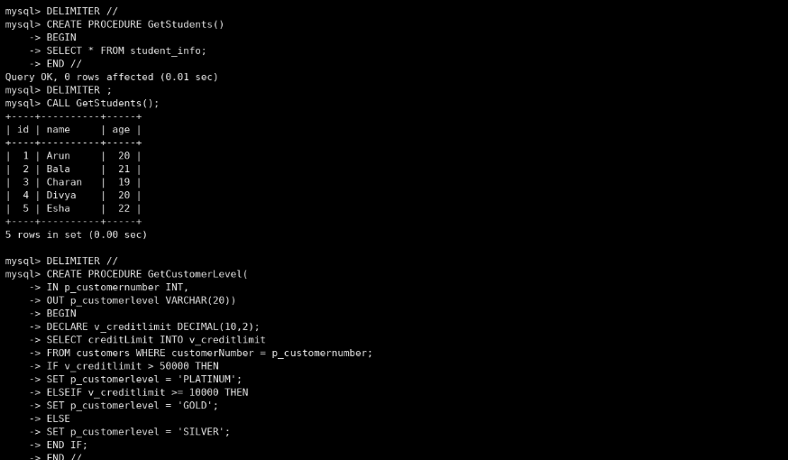
RESULT:
Thus the Functions using program in MySQL executed successfully .

